**Experiment 3.1 Paul Thomas 30 S3 CSB**

**Program**

| import java.io.*;  public class filehandling{  public static void main(String[]args) throws Exception{  File inf = new File("in.dat"); //create a file in.dat and add any text there  File outf = new File("out.dat");  FileReader ins = new FileReader(inf);  FileWriter outs = new FileWriter(outf);  int ch;  while((ch=ins.read()) != -1){  outs.write(ch);  }  if(outs != null)  System.out.println("Content written Successfully");  ins.close();  outs.close();  }  } |
| --- |

Program

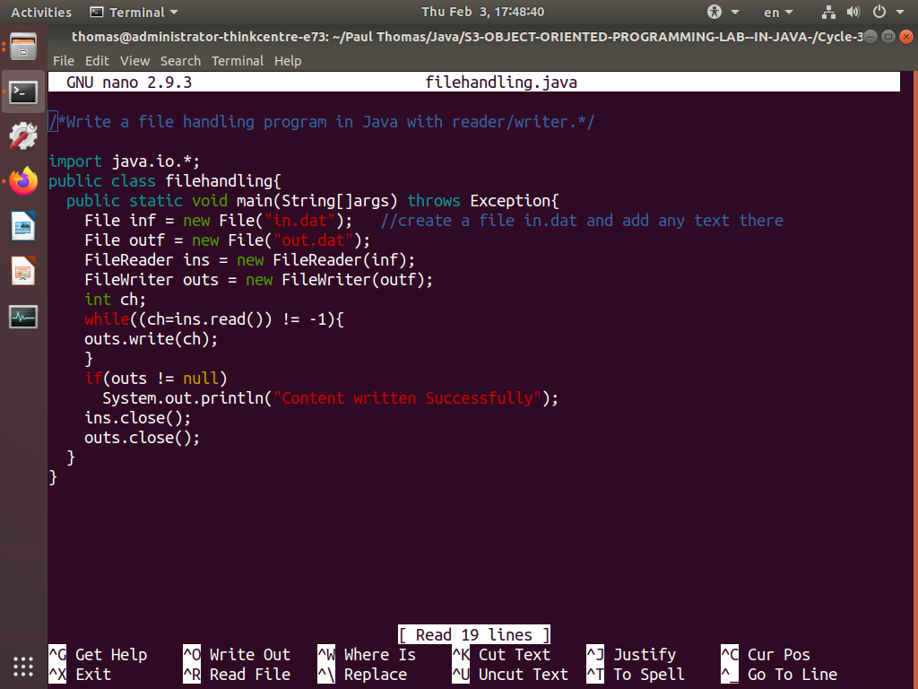

Output

